1. Write a python code to display System information?

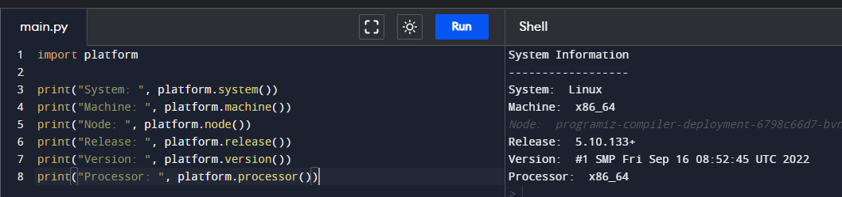

1. Write a python code for magic pot?
2. Write a python code to find prime or not?

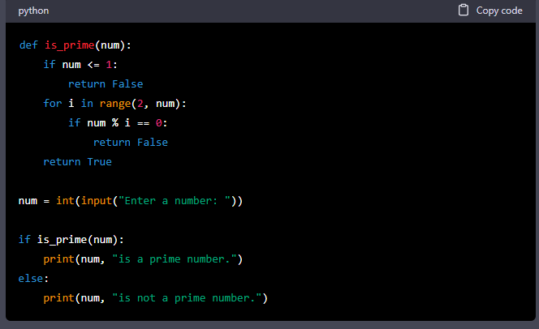

1. Write a python code for simple calculator?

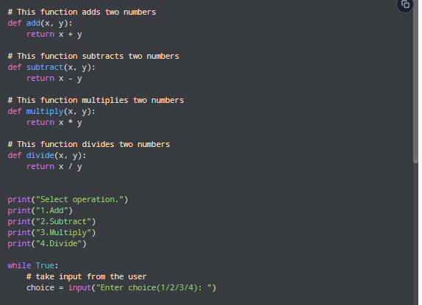

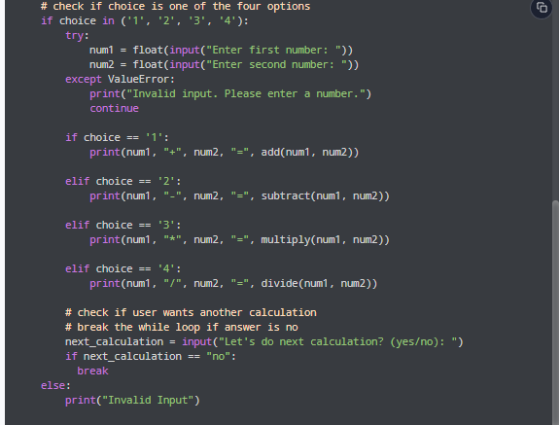

1. Write a python code to find factorial?

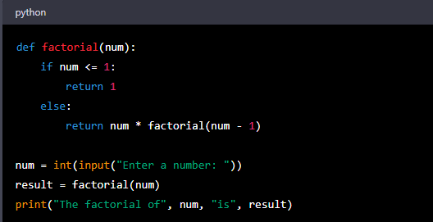

1. Write a python code Fibonacci series?

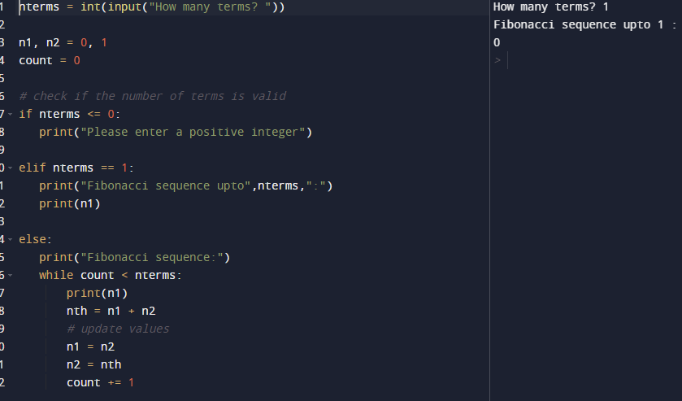

1. Write a python code grade calculation? 80> A | 60 > b | 40 > c using elif?

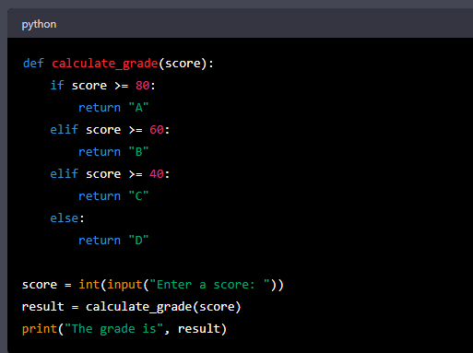

1. Write a python code sum of n numbers using while loops?

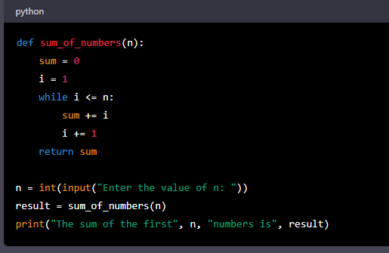

1. Write a python code for string handling functions?(Any ten)

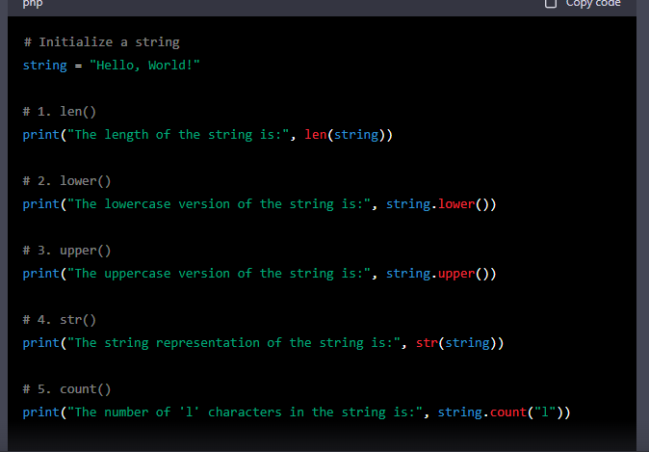

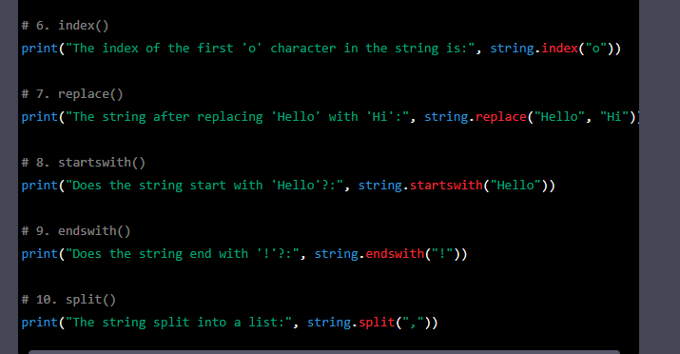

1. Write a python code to find employee gross salary? i.e. p.f

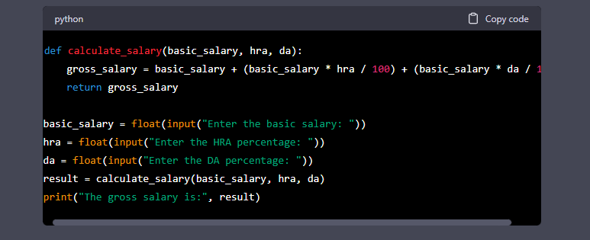

1. Write a python code list?

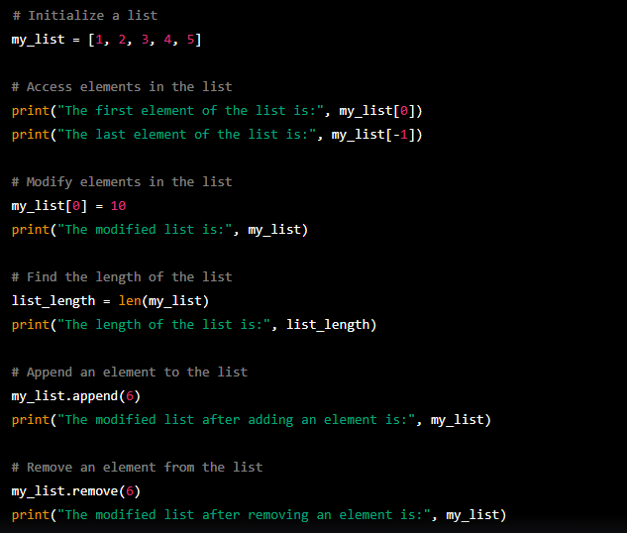

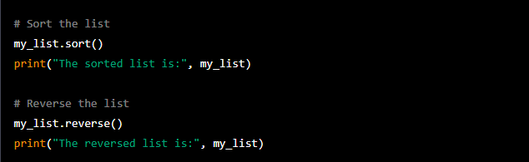

1. Write a python code Set?

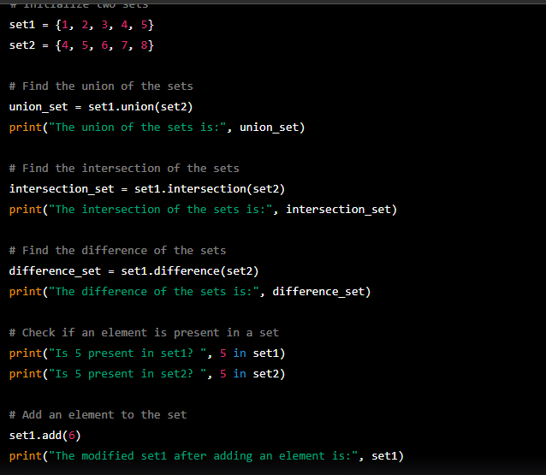

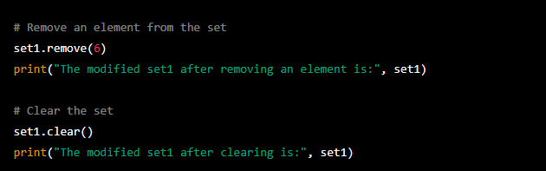

1. Write a python code Dictionaries?

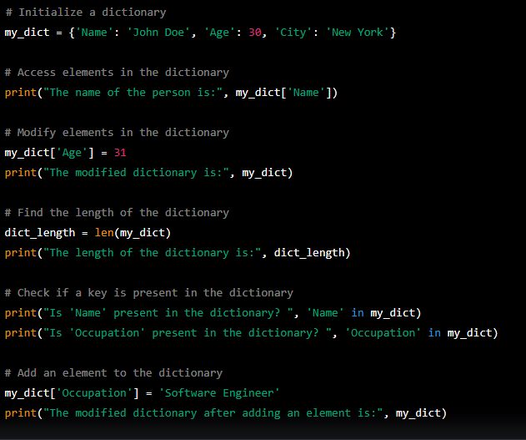

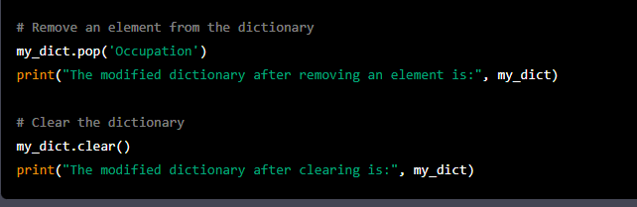

1. Write a python code tuples?

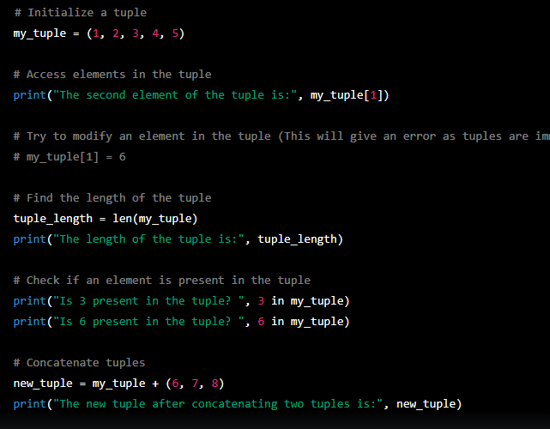

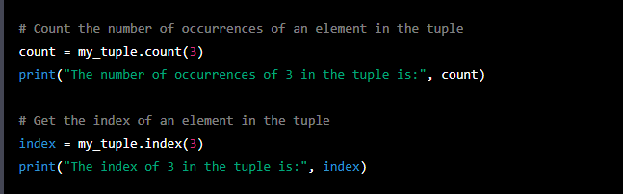

1. Write a python code Arithmetic Operators?

